*Use Case Model Diagram*

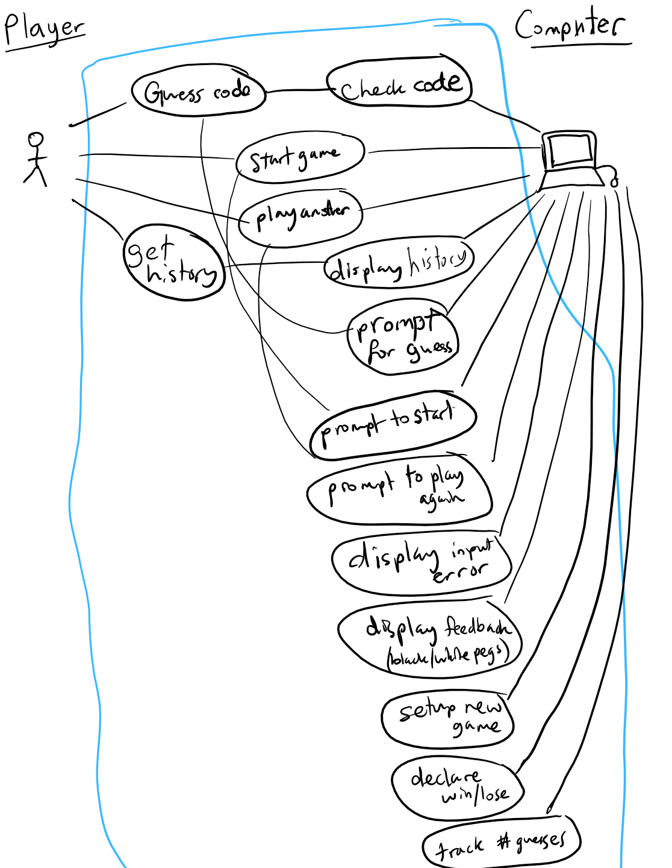  


*Class Diagram*

Driver

Player

- State: ready

- Scanner: scan

+ guess(): String

+ startGame(): ready

+ playAnother(): ready

+ showHistory(): null

Code

-Sequence: pegs

- Colors: colors

- Pegs in a Row: pegNumber

+compare(Code c): boolean[]

+equals(Object c): boolean

+toString(): String

+getPegs(): pegs

Game

- Turns: history

- This turn: round

- State: testing, playing

- Max turns: guessNumber

- Colors: colors

- Pegs in a Row: pegNumber

+declareResult(): void

+showHistory(): void

+addHistory(String feedback): void

+feedback(String guess, int[] result): String

+getRound(): round

+addRound(): round

+runGame(int count): int

Computer

- Secret: secret

- Colors: colors

- Pegs in a Row: pegNumber

+ checkGuess(Code c):int[]

+ getSecret(): secret

GameConfiguration

Max turns: guessNumber

Colors: colors

Pegs in a Row: pegNumber

Full name of colors allowed: colorsString

Message

- Messages: bank

- Instance message: myMsg

+ prompt(int msgNum): String

+ prompt(String msgName): myMsg

+ 6 special string format methods…

*Sequence Diagram 1 (Game Runner)*

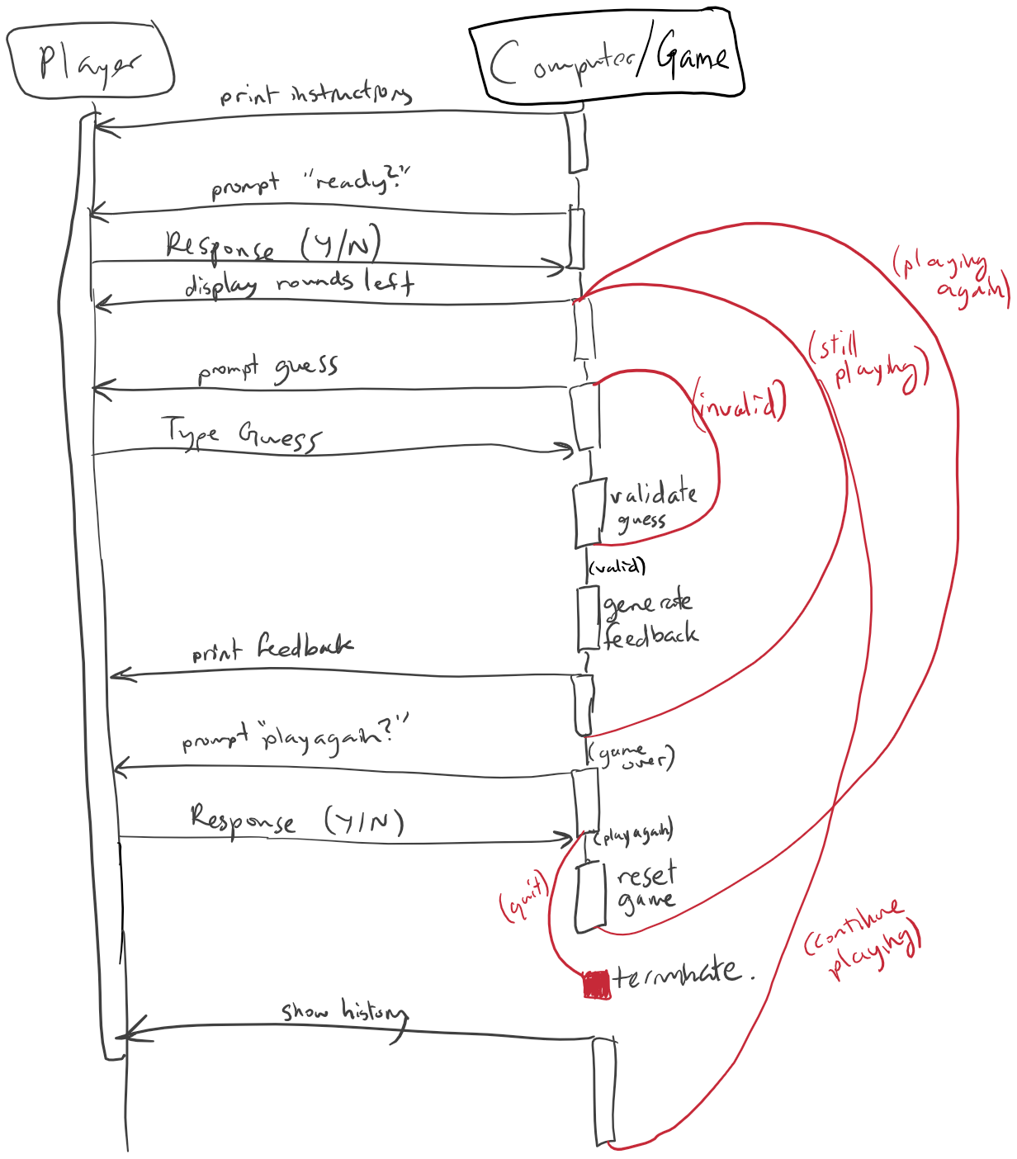



*Sequence Diagram 2 (Feedback)*

